Artificial Intelligence  AI-2002 | Lab 11  Unsupervised Learning

National University of Computer & Emerging Sciences – NUCES – Karachi

Course Code: AI-2002 | Artificial Intelligence Lab

1. Objective 3
2. Machine Learning and Its Types 3
2.1 Libraries Used in Machine Learning 4
3. Introduction to Supervised Learning 4
3.1 Applications of Unsupervised Learning 5
3.2 Types of Unsupervised Learning 5
4. Clustering 6
4.1 K means 6

1. Objective
- The fundamentals of machine learning and its various types.
- How supervised learning differs from other types of machine learning.
- The usage of Python libraries like NumPy, Pandas, Matplotlib, and Scikit-learn for implementing machine learning algorithms.
- Practical implementation of supervised learning classification algorithms such as Linear Regression, Logistic Regression and SVM.
- Some examples of regression algorithms like Decision Trees.

2. Machine Learning and Its Types
Machine learning is a subset of artificial intelligence that enables systems to learn from data and improve their performance without explicit programming. It is broadly categorized into three types:

Machine Learning
Supervised Learning
Unsupervised Learning
Reinforcement Learning
Classification
Regression
Clustering
Association
Reward
Decision Process
Recommender Systems
Dimensionality Reduction

2.1 Libraries Used in Machine Learning
Below mentioned Python libraries are commonly used to implement machine learning algorithms:
- NumPy: Provides support for numerical computations and working with arrays.
- Pandas: Facilitates data manipulation and analysis.
- Matplotlib: Used for data visualization.
- Scikit-learn: A comprehensive library for implementing both supervised and unsupervised learning algorithms. It also provides tools for data preprocessing, model selection, and evaluation metrics.
- Seaborn: Enhances data visualization by providing advanced plotting functions.

3. Introduction to Unsupervised Learning
Unsupervised Learning is a type of machine learning where the model is not given any labeled data. Instead of being told what the correct output is, the model tries to find patterns or structure in the data on its own. The algorithm learns from the data itself — without guidance or answers.
Unsupervised learning cannot be directly applied to a regression or classification problem because unlike supervised learning, we have the input data but no corresponding output data. The goal of unsupervised learning is to find the underlying structure of dataset, group that data according to similarities, and represent that dataset in a compressed format.

Example: Suppose the unsupervised learning algorithm is given an input dataset containing images of different types of cats and dogs. The algorithm is never trained upon the given dataset, which means it does not have any idea about the features of the dataset. The task of the unsupervised learning algorithm is to identify the image features on their own. Unsupervised learning algorithm will perform this task by clustering the image dataset into the groups according to similarities between images.

Why use Unsupervised Learning?
Below are some main reasons which describe the importance of Unsupervised Learning:

- Unsupervised learning is helpful for finding useful insights from the data.
- Unsupervised learning is much similar as a human learns to think by their own experiences, which makes it closer to the real AI.
- Unsupervised learning works on unlabeled and uncategorized data which make unsupervised learning more important.
- In real-world, we do not always have input data with the corresponding output so to solve such cases, we need unsupervised learning.

Working of Unsupervised Learning
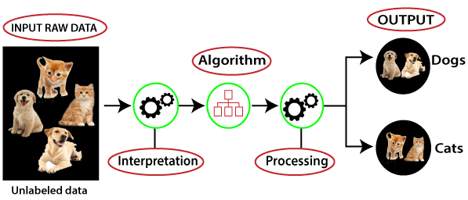

3.1 Applications of Unsupervised Learning
- Customer Segmentation
- Document or News Clustering
- Music or Movie Recommendation

3.2 Types of Unsupervised Learning
There are three types of Unsupervised learning algorithms defined as follows:
- Clustering: Clustering is a way of grouping similar things together. In machine learning and data science, clustering is used to group similar data points into clusters, so that items in the same cluster are more alike than those in other clusters. It is an unsupervised learning technique, which means it works without labeled data.

- Association: An association rule is an unsupervised learning method which is used for finding the relationships between variables in the large database. It determines the set of items that occur together in the dataset. Association rule makes marketing strategy more effective. Such as people who buy X item (suppose a bread) are also tend to purchase Y (Butter/Jam) item. A typical example of Association rule is Market Basket Analysis.
- Dimensionality Reduction: Dimensionality Reduction is the process of reducing the number of features (columns) in your dataset while keeping the important information. It helps simplify complex data, makes it easier to visualize, and often speeds up machine learning algorithms.

4. Clustering

4.1 K-Means clustering
K-Means Clustering is an Unsupervised Learning algorithm, which groups the unlabeled dataset into different clusters. Here K defines the number of pre-defined clusters that need to be created in the process, as if K=2, there will be two clusters, and for K=3, there will be three clusters, and so on.

It is an iterative algorithm that divides the unlabeled dataset into k different clusters in such a way that each dataset belongs to only one group that has similar properties.

The k-means clustering algorithm mainly performs two tasks:
- Determines the best value for K center points or centroids by an iterative process.
- Assigns each data point to its closest k-center. Those data points which are near to the particular k-center, create a cluster.
Hence each cluster has datapoints with some commonalities, and it is away from other clusters.

The below diagram explains the working of the K-means Clustering Algorithm:
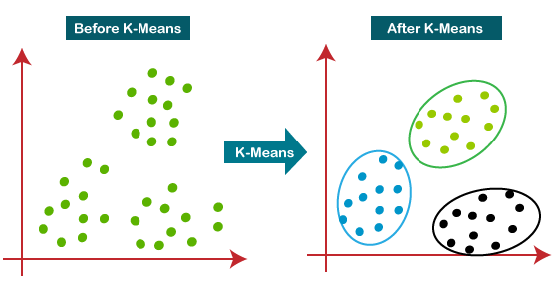

Elbow Method: The Elbow method is one of the most popular ways to find the optimal number of clusters. This method uses the concept of WCSS value. WCSS stands for Within Cluster Sum of Squares, which defines the total variations within a cluster. The formula to calculate the value of WCSS (for 3 clusters) is given below:

WCSS= ∑Pi in Cluster1 distance(Pi C1)2 +∑Pi in Cluster2distance(Pi C2)2+∑Pi in CLuster3 distance(Pi C3)2
In the above formula of WCSS,

∑Pi in Cluster1 distance(Pi C1)2: It is the sum of the square of the distances between each data point and its centroid within a cluster1 and the same for the other two terms.

To measure the distance between data points and centroid, we can use any method such as Euclidean distance or Manhattan distance.

To find the optimal value of clusters, the elbow method follows the below steps:
- It executes the K-means clustering on a given dataset for different K values (ranges from 1-10).
- For each value of K, calculates the WCSS value.
- Plots a curve between calculated WCSS values and the number of clusters K.
- The sharp point of bend or a point of the plot looks like an arm, then that point is considered as the best value of K.
Since the graph shows the sharp bend, which looks like an elbow, hence it is known as the elbow method. The graph for the elbow method looks like the below image:

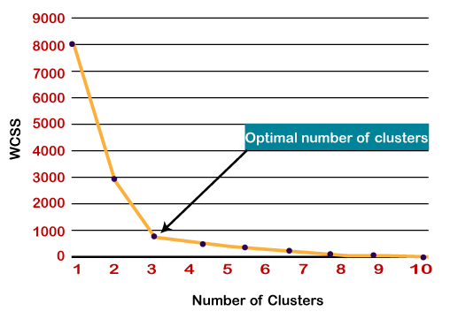

4.1.1 How does the K-means algorithm works
Step-1: Select the number K to decide the number of clusters.
Step-2: Select random K points or centroids. (It can be other from the input dataset).
Step-3: Assign each data point to their closest centroid, which will form the predefined K clusters.
Step-4: Calculate the variance and place a new centroid of each cluster.
Step-5: Repeat the third steps, which means reassign each datapoint to the new closest centroid of each cluster.
Step-6: If any reassignment occurs, then go to step-4 else go to FINISH.
Step-7: The model is ready.

4.1.2 HOW TO IMPLEMENT K-means clustering?
- - - - - - - - - -- - - - - - - - - - - - - - – - - – - - - - - - - - - - - - - - - - - - - - - - - - - - - - - - - - - - - - - -
#importing libraries
import numpy as nm
import matplotlib.pyplot as mtp
import pandas as pd
from sklearn.cluster import KMeans
from sklearn.preprocessing import StandardScaler

# Importing the dataset
df = pd.read_csv('Mall_Customers.csv')
df.head()

# Extracting Variables
x = df.iloc[:, [3, 4]].values

#finding optimal number of clusters using the elbow method
from sklearn.cluster import KMeans
wcss_list= [] #Initializing the list for the values of WCSS

#Using for loop for iterations from 1 to 10.
for i in range(1, 11):
kmeans = KMeans(n_clusters=i, init='k-means++', random_state= 42)
kmeans.fit(x)
wcss_list.append(kmeans.inertia_)
mtp.plot(range(1, 11), wcss_list)
mtp.title('The Elobw Method Graph')
mtp.xlabel('Number of clusters(k)')
mtp.ylabel('wcss_list')
mtp.show()

# Normalize features for better clustering
scaler = StandardScaler()
X_scaled = scaler.fit_transform(x)

#training the K-means model on a dataset
kmeans = KMeans(n_clusters=5, init='k-means++', random_state= 42)
y_predict= kmeans.fit_predict(X_scaled)

#visulaizing the clusters
mtp.scatter(x[y_predict == 0, 0], x[y_predict == 0, 1], s = 100, c = 'blue', label = 'Cluster 1') #for first cluster
mtp.scatter(x[y_predict == 1, 0], x[y_predict == 1, 1], s = 100, c = 'green', label = 'Cluster 2') #for second cluster
mtp.scatter(x[y_predict== 2, 0], x[y_predict == 2, 1], s = 100, c = 'red', label = 'Cluster 3') #for third cluster
mtp.scatter(x[y_predict == 3, 0], x[y_predict == 3, 1], s = 100, c = 'black', label = 'Cluster 4') #for fourth cluster
mtp.scatter(x[y_predict == 4, 0], x[y_predict == 4, 1], s = 100, c = 'purple', label = 'Cluster 5') #for fifth cluster
mtp.scatter(kmeans.cluster_centers_[:, 0], kmeans.cluster_centers_[:, 1], s = 300, c = 'yellow', label = 'Centroid')
mtp.title('Clusters of customers')
mtp.xlabel('Annual Income (k$)')
mtp.ylabel('Spending Score (1-100)')
mtp.legend()
mtp.show()

- - - - - - - - - - - - - - - - - - - - - - - - - - - - - - - - - - - - - - - - - - - - - - - - - - - - - - - - - - - - - - - - - - -

LAB TASK
TASK # 1
In the example code above, customer segmentation was performed using only two features. Now, use all available features except customer_id to implement K-Means clustering. Perform the clustering twice — once without feature scaling, and once with scaling applied to all features except age. Compare the results and comment on the differences and insights observed from these changes.

TASK # 2
A transportation company wants to optimize its routes and fleet by categorizing different types of vehicles based on their usage patterns. The company has data on several features such as: vehicle_serial_no, mileage, fuel_efficiency, maintenance_cost, and vehicle_type. The goal is to create segments of vehicles based on these attributes to help with fleet management. Implement K-Means clustering to group vehicles using all the features. Perform the clustering twice: once without scaling the features and once with scaling applied to all features (except for vehicle_type, which is categorical). Analyze and compare the results, focusing on how the scaling affects the clustering output.

Sample Data:
# Example vehicle data
data = {
‘vehicle_serial_no’: [5, 3, 8, 2, 4, 7, 6, 10, 1, 9],
'mileage': [150000, 120000, 250000, 80000, 100000, 220000, 180000, 300000, 75000, 280000],
'fuel_efficiency': [15, 18, 10, 22, 20, 12, 16, 8, 24, 9],
'maintenance_cost': [5000, 4000, 7000, 2000, 3000, 6500, 5500, 8000, 1500, 7500],
'vehicle_type': ['SUV', 'Sedan', 'Truck', 'Hatchback', 'Sedan', 'Truck', 'SUV', 'Truck', 'Hatchback', 'SUV']
}
# Create a DataFrame
df = pd.DataFrame(data)

TASK # 3
The academic affairs department at FAST NUCES Karachi is looking to identify distinct groups of students based on their academic engagement and performance. The department has access to anonymized student data containing the attributes student_id, GPA, study_hours (average weekly study hours), and attendance_rate (percentage of classes attended).
The goal is to group students into meaningful clusters that can help tailor academic support programs, such as extra tutoring, mentoring sessions, or motivation workshops.
You are required to perform unsupervised learning using K-Means clustering on the student dataset. Do following :
- Feature Selection and Scaling: Use the following features for clustering: GPA, study_hours, and attendance_rate.
- Apply appropriate feature scaling before clustering.
- Determine Optimal Number of Clusters (K): Use the ELbow method to determine the optimal number of clusters (K) in the range of 2 to 6.
- Perform Clustering: Apply K-Means using the optimal K and assign a cluster label to each student.
- Visualization: Create a scatter plot to visualize the clusters using study_hours and GPA as the axes.
- Color each point based on its cluster.
- Add an informative title and labels for clarity.
- Deliverables: Display the final dataset showing student IDs along with their assigned cluster.
- Present the scatter plot that illustrates the clustering result.

